Lakewood Family News!
October 6, 2019
OCTOBER BIRTHDAYS!
Dawn Coulter 4TH , Debra W. Loy 10TH, Lindy McKinney 18TH, Randall Demonbreun 19TH, Wynotta Morrell 22ND,

PRAYER TIME AT THE ALTAR!
Please join us in the Sanctuary each Sunday morning before Sunday School from 9:15 am to 9:30 am for a time of Spirit-filled prayer! Even if you’re a few minutes late and we’ve started praying, please come in and join us at the altar. It’s truly a great way to start your Sunday morning!

2019 -2020 Golden State Mission Offering -
For Tennessee Missions! GO HARVEST
“I tell you, open your eyes and look at the fields!
They are ripe for harvest.” John 4:35b
Our Church Goal: $1,000.00 Donations to date: $530.00
Offering Envelopes are located in the pews.
WORKDAY AT THE PARSONAGE!
Saturday, October 12 at 8:00 a.m.
Inside work. We will be doing some painting.

50 PLUS LUNCHEON
This Photo by Unknown Author is licensed under CC BY-SA
Thursday, October 17 at 11:30 a.m.
Potluck Luncheon. Bring food for you and few friends. Come enjoy the Food & Fellowship!

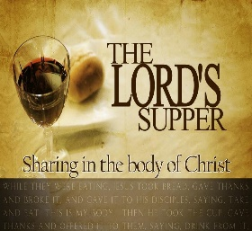
This Photo by Unknown Author is licensed under CC BY-SA-NC
We will celebrate
The Lord’s Supper next Sunday, October 13 at
10:45 am

